USTX prototype

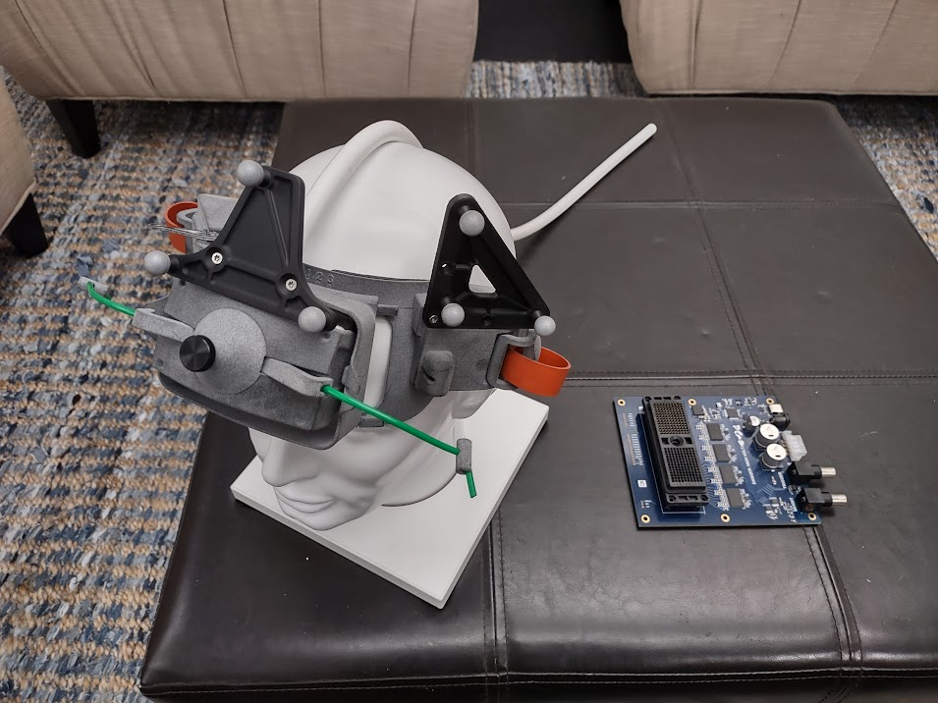
Figure 1

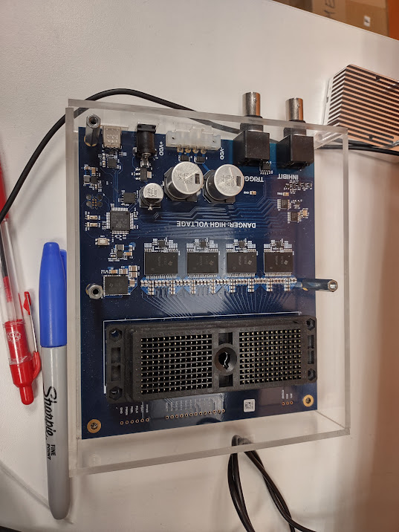
Figure 2
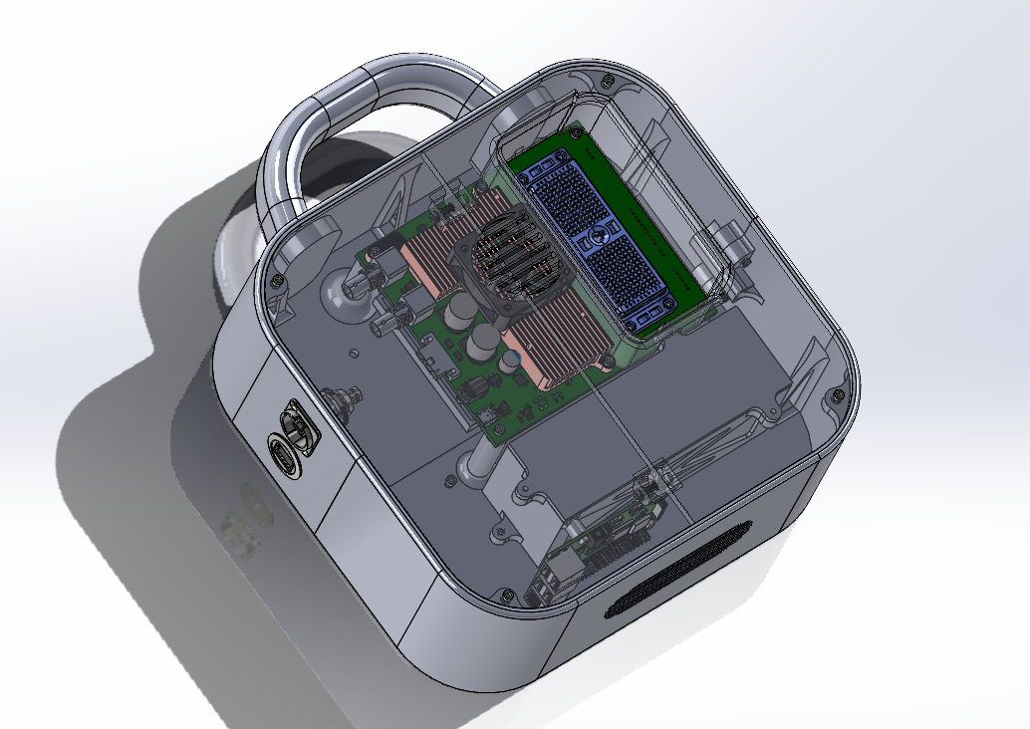
Figure 3
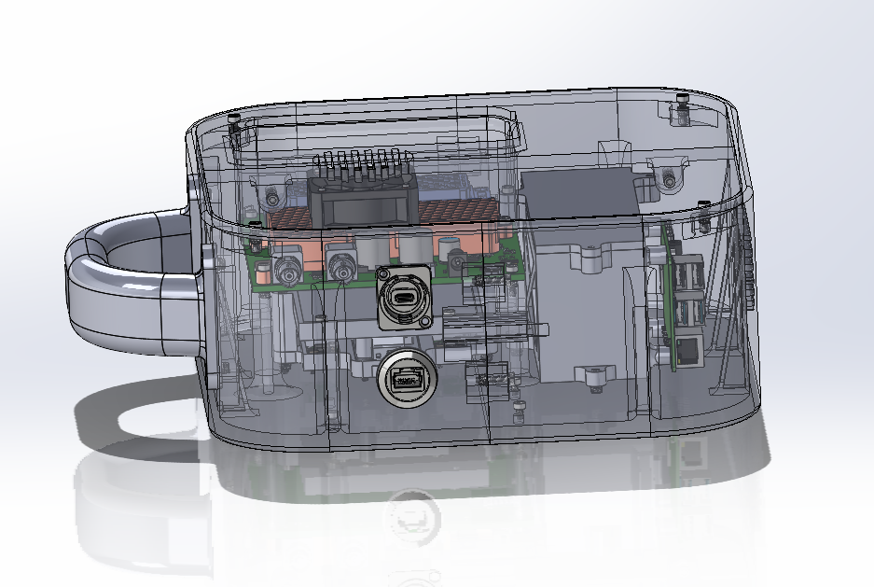
Figure 4

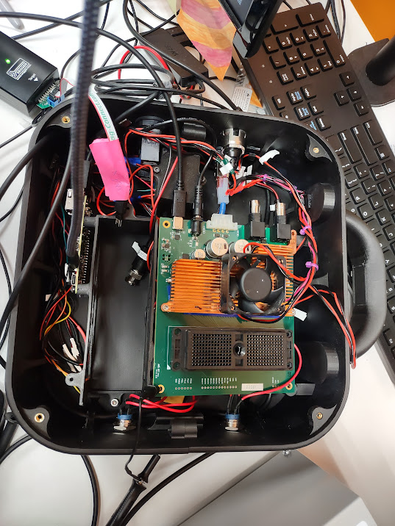
Figure 5 prototype

The USTX 1-2 .zip is the altium file download
Compact USTX driuper.zip is a compressed file with the native solidworks files
Compact USTX .step is a solid model of the assembly
Compact USTX.easm is a e-drawing or an assembly that can be opened with a free viewer

